1. Name : Ahmed Tarek Mohammed Ahmed Hassan

Universal id : 18010147

1. Name : Mohamed Metwalli Noureldin Mahmoud

Universal id : 18011587

1. Name : Omar Ashraf Kotb Mohammed Elshanshory

Universal id : 18011111

The project report

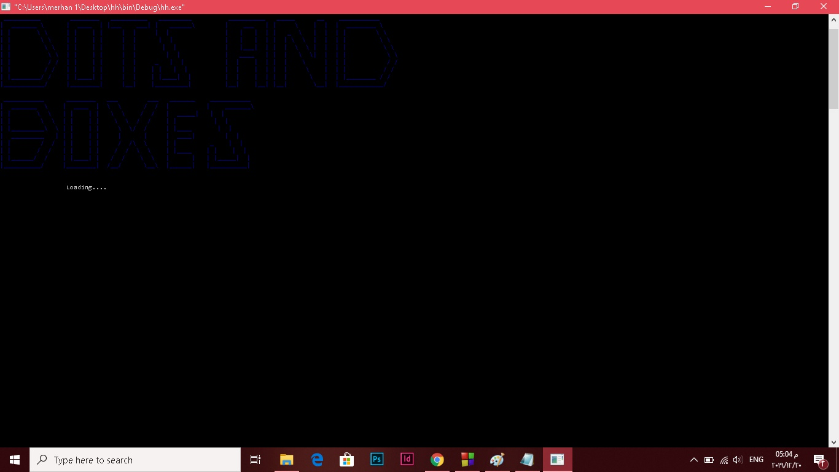

Description:

This game begins with a grid (2*2 in beginner 5*5 in expert) then the players choose the place which they want to draw a line in by entering row and column of that place, if a player chose a line that close a box so his score increase by one and he plays another turn.

There is two mode 2 players mode and computer mode.

Features:

-Each player has his color player 1 has blue color player 2 has red color .

-The game can be saved by two ways :

1-User can choose the file which he want to save in (he can choose between 3 files ).

2-User can save without choosing a particular file.

-User can load the game he saved.

-User can use the rank to his order.

-The game has 2 time counter:

1- Timer for the game time elapsed.

2- Timer for the time taken by player to choose a line.

Design Overview:

1-In beginner mode: it contains 4 boxes,12 line and 9 dots

2-In expert mode it contains 25 boxes, 60 line and 36 dots

3-Remaning lines to be drawn.

4-Score for each player.

5-Moves of each player .

6- Timer for the elapsed game.

7-Player turn

8-Each of that fields are colored by the player color.

Assumptions:

1-we assume that player one plays first (even) in both modes.

2-Player 1 when close a box “ A” is drawn inside the box, player “ B ” is drawn inside the box each with his color.

3-Vertical line is when row(r) is odd and column(c) is even .

4-Horzintal line is when row(r) is even and column(c) is odd.

5-Dots is when both are even

Data Structure:

Structure:

1-Player structure contain name and score of the players and computer.

**Arrays:**

**Gridarray:**

A 3d array take 3 numbers as below:

|  |  |  |
| --- | --- | --- |
| n | n | 0 |

-n is for the size of grid (5*5 in beginner 11*11 in expert)

-0 is for player 1

|  |  |  |
| --- | --- | --- |
| n | n | 1 |

-1 is for player 2 and for computer in computer mode

-So this 3d array help us to differentiate between the 2 player and between the player and computer.

**Example:**

When we want to print a line drawn by player 1 by his color the array is same to this : gridarray[r][c][0] then prints by nested loop.

Where r and c is row and column of the place player1 want to draw his line.

Functions:

1-human :

For 2 players mode

2-computer:

For computer mode

**Flow chart:**

Computer logic flow chart

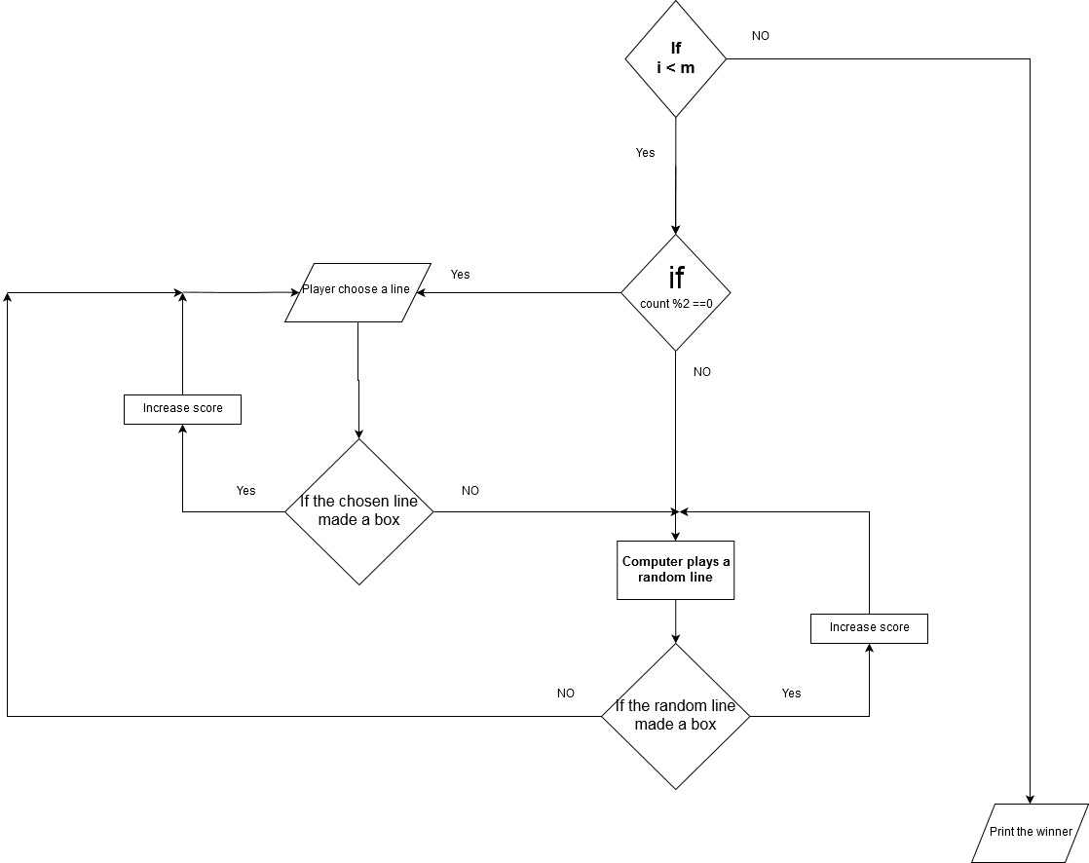

Game flow chart

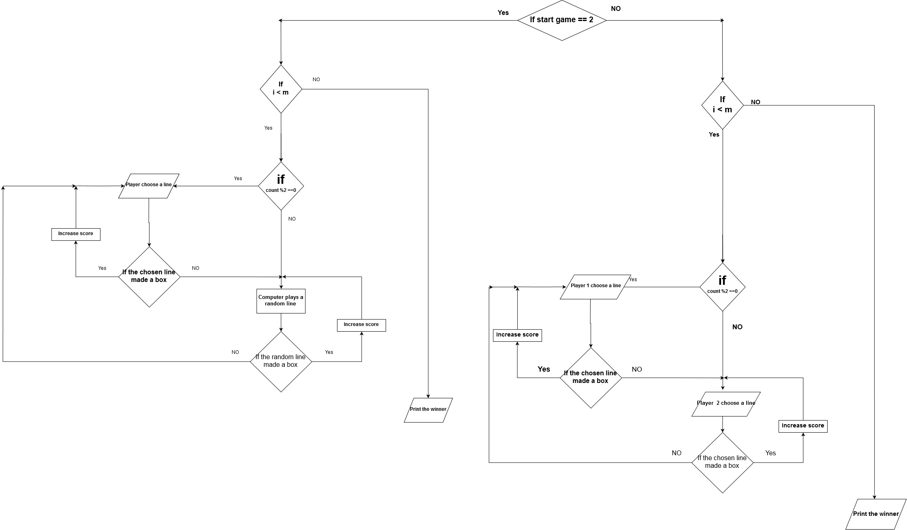

**pseudo code:**

**Game pseudo code**

-Run the game

-If startgame = 1 go to 2 players mode .

-If gamemode = 1 go to beginner mode.

- n = 5 , m = 12

-Else if gamemode = 2 go to expert mode

- n = 11 , m = 60 .

-**If**  i = 0 , i < m .

-Ask user for input to draw a line .

-If count %2 = 0 (even)

player 1 will play.

-Else

player 2 will play.

-Read player input.

-If player’s last input closes a box .

-Increment his score by 1 or 2 if he closes 2 boxes .

-Increment count by 1 so that the player plays again.

-Else

the other player will play.

**-Else**

**-**Print the winner.

-Else if startgame = 2 go to computer mode.

-If gamemode = 1 go to beginner mode.

- n = 5 , m = 12

-Else if gamemode = 2 go to expert mode

- n = 11 , m = 60 .

-**If**  i = 0 , i < m .

-If count % 2 = 0

-Read input from user

-Else

-Computer will play a random line

-If user or computer last line chosen closes a box

-Increment his score by 1 or 2 if he closes 2 boxes .

-Increment count by 1 so that the player plays again.

-Else

the other player will play.

**-Else**

**-**Print the winner.

**Computer logic pseudo code**

-**Do**

- r = rand() % n

- c = rand() % n

**-While** grid = “ | ” or grid = “ - ” or grid = its dots

So if this condition is false loop will terminate with computer’s true line.

User Manual:

1. To gain point : you should close a square of size 1x1.

2. When you get a point you will have an extra

move .

How to input :

you enter the number of the row of the line on the grid then space then you enter the number of the column of the same line on the grid then press Enter .

Some notes for playing :

1-To undo a play , you should enter '0 0' in the

input.

2-To save the game in file number 1 , you should enter '1 1' in the input.

3-To save the game in file number 2 , you should enter '2 2' in the input.

4-To save the game in file number 3 , you should enter '3 3' in the input.

5-To save the game in a file chosen randomly , you should enter '4 4' in the input.

6-To load the game , choose 'Load game' from the

menu and then choose whether the saved game was played between 2 players or between a player and the computer

then choose the game number (game number1 or game number2 or game number3 ).

**Sample runs:**

-**Menu**

press 1 to start game , 2 to see instructions , 3 for rank and 4 to quit.

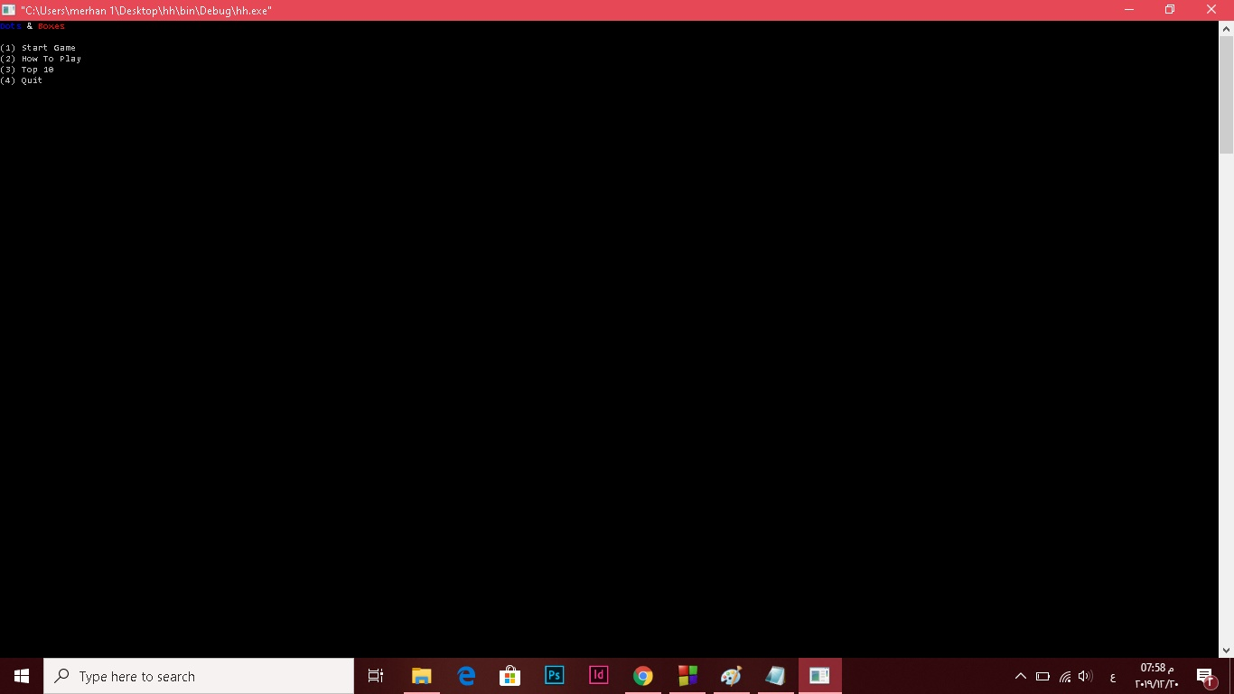

-Load: load game 1 press 1 ,game 2 press 2 and game 3 press

3

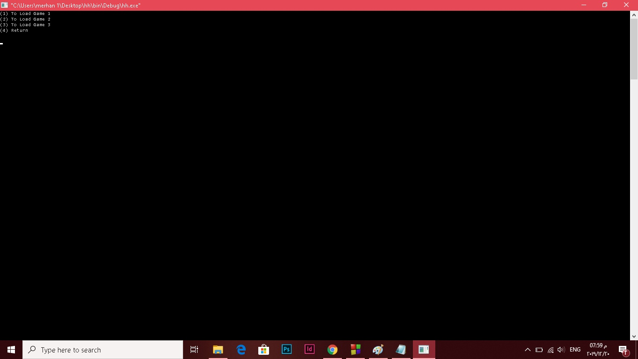

Ask about the mode press 1 for 2 players , 2 for computer

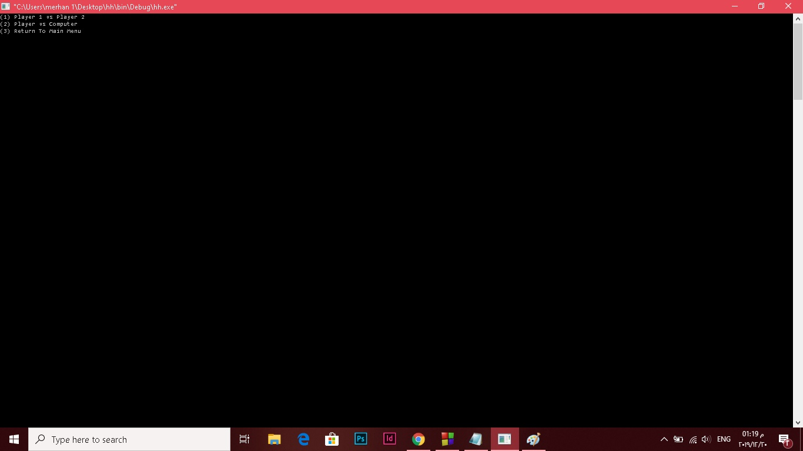

-Ask about beginner(press 1) or expert(press 2)

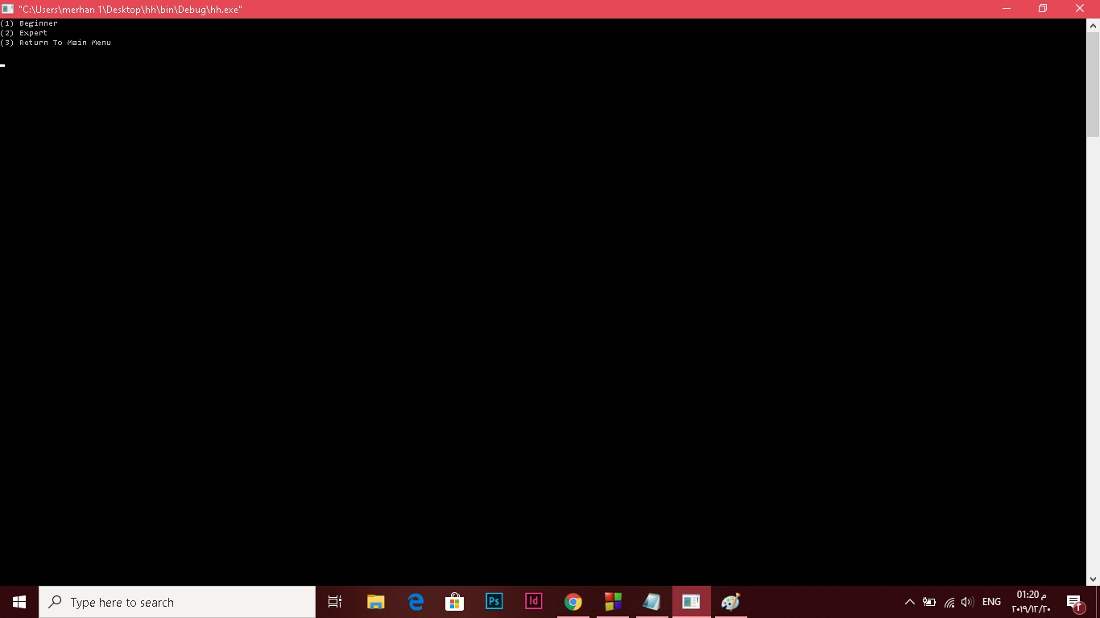

-Beginner grid

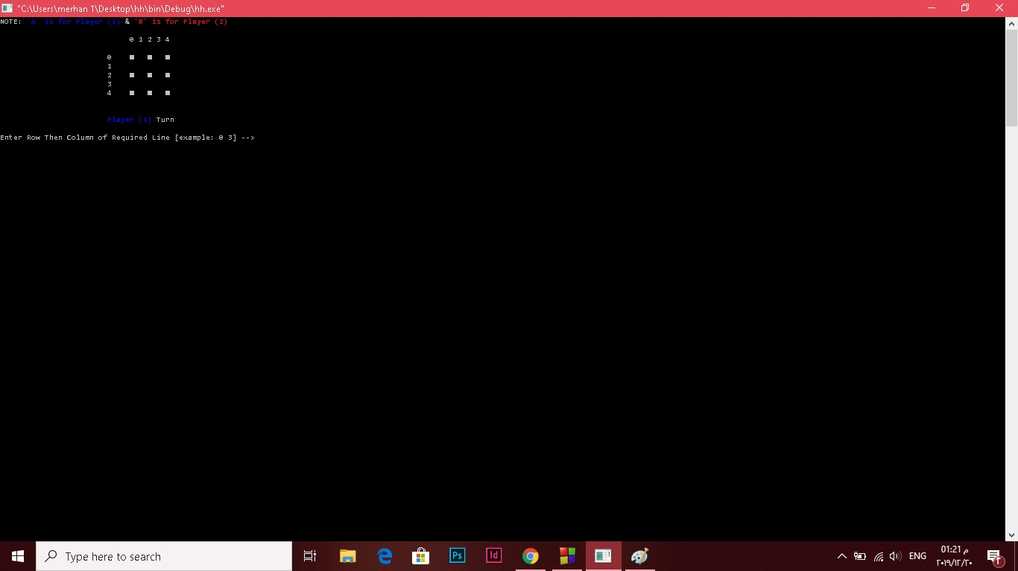

-Expert grid

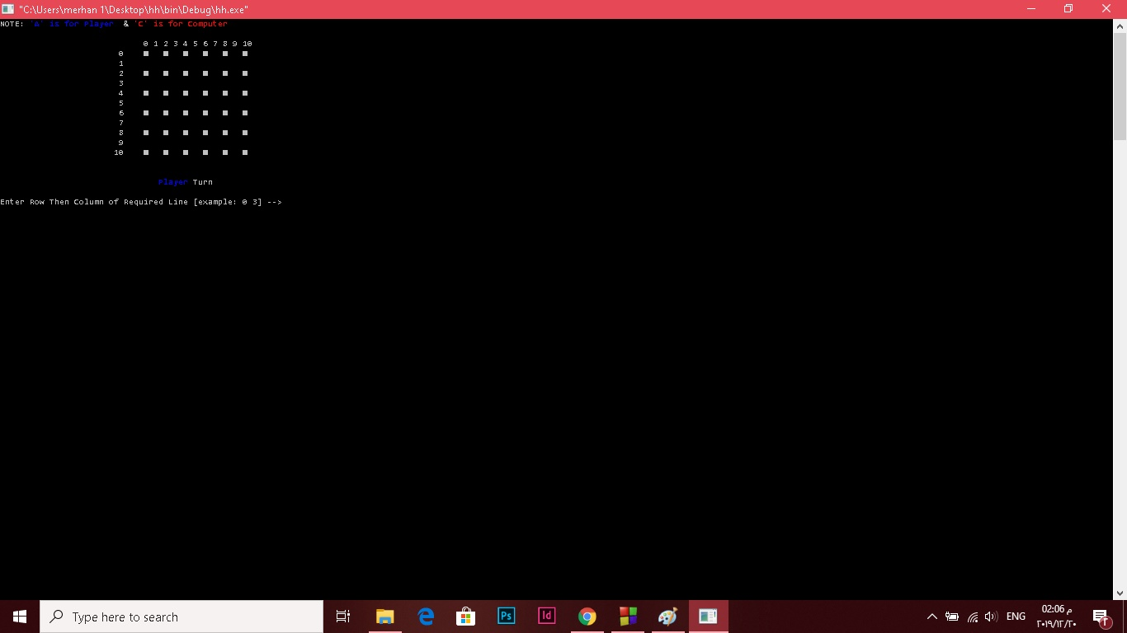

Rank

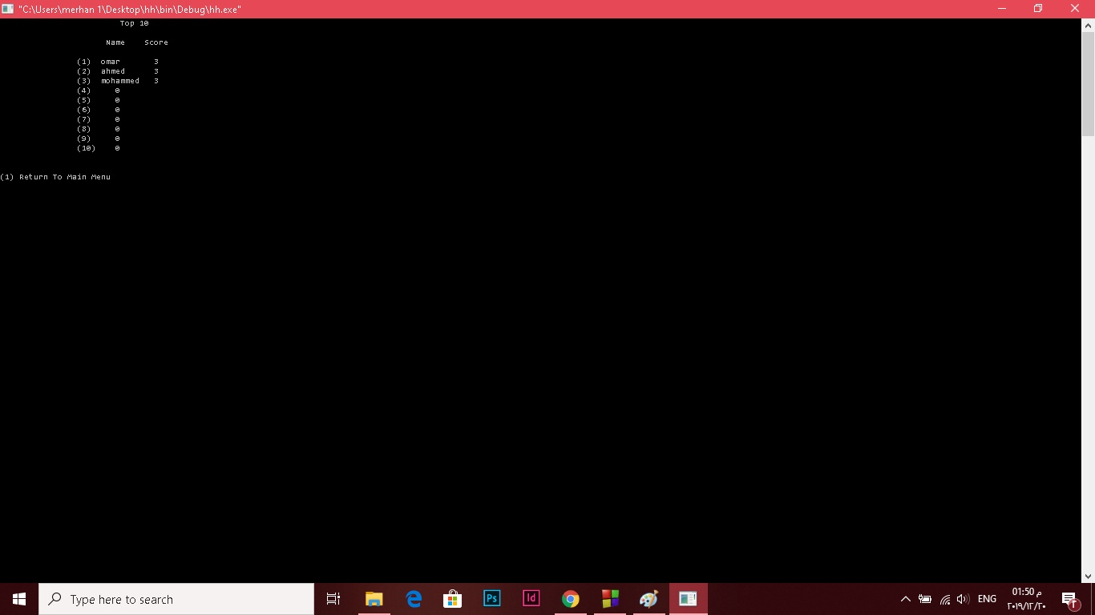

-INPUT: When player 1 enter row and column a blue line is drawn when player 2 a red line is drawn.

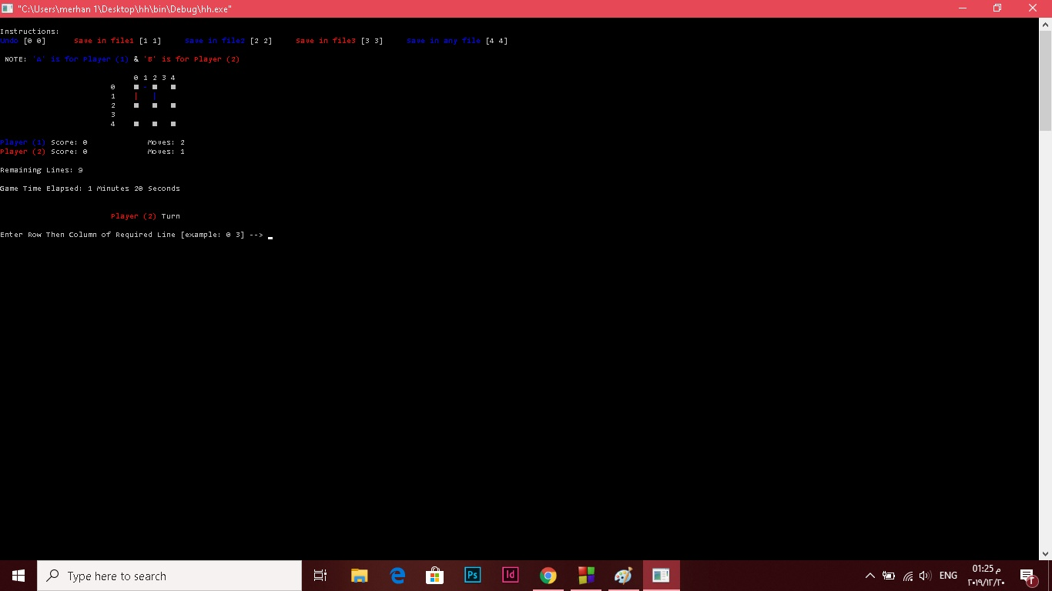

Scoring a point :when player 1 closes a box it writes in it

“ A ” with blue color and he gains another turn

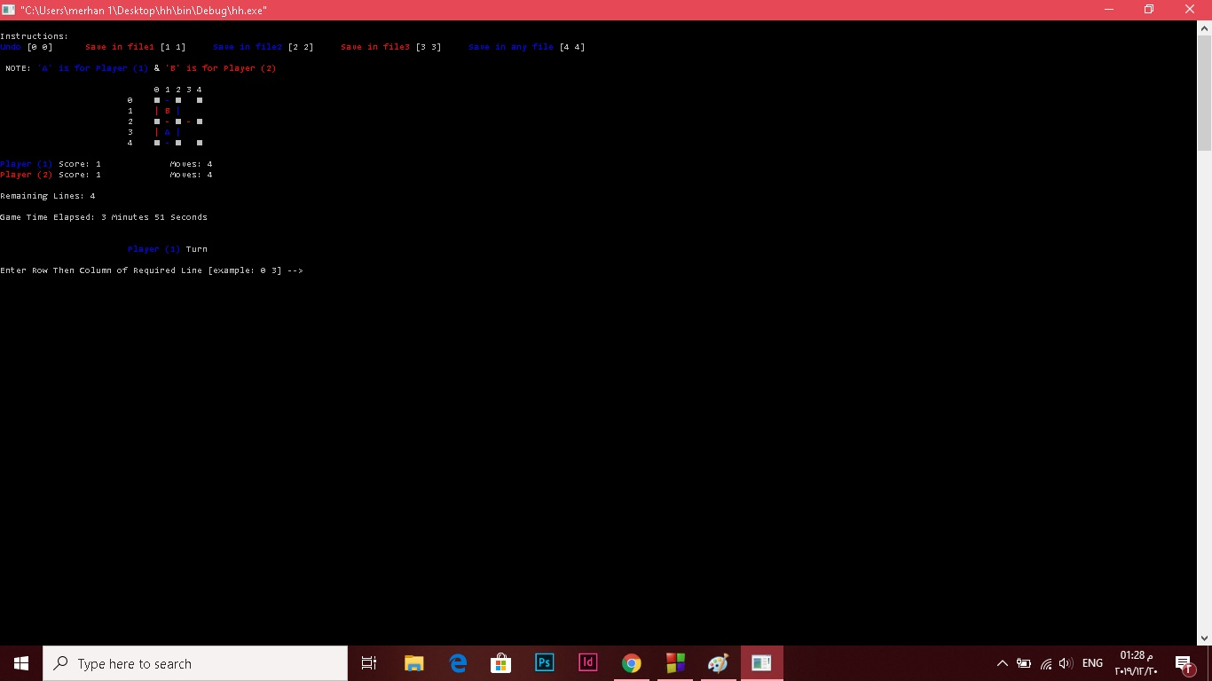

-In computer mode

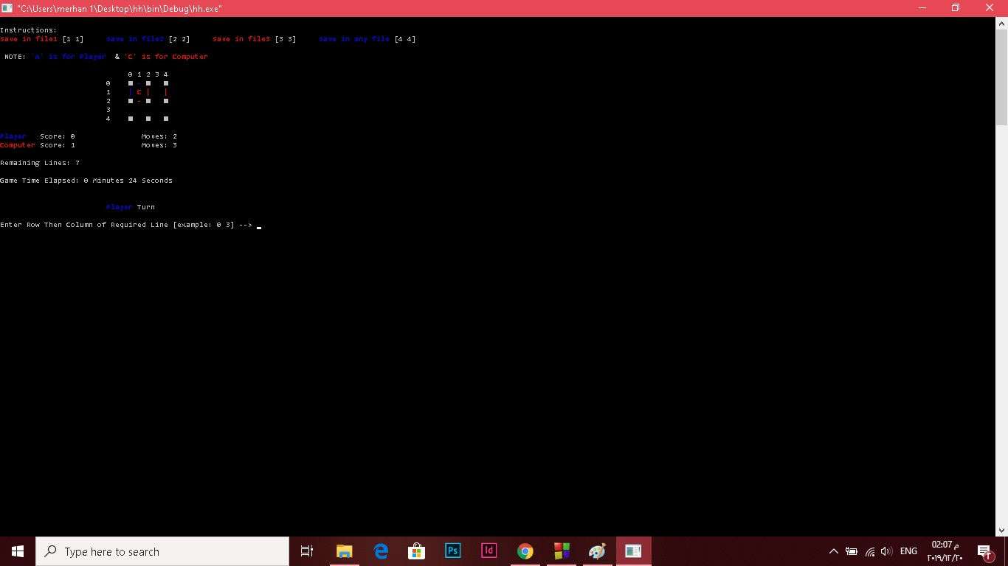

**References:**

**Time:** [https://www.techiedelight.com/find-execution-time-c-program/](https://www.techiedelight.com/find-execution-time-c-program/?fbclid=IwAR1cfJ83OB4Id7QE64yM9oDlJd4N1snYKAJP4xdyg_uznfmreJdqnKm54h8)

**Colors:** [http://web.theurbanpenguin.com/adding-color-to-your-output-from-c/](http://web.theurbanpenguin.com/adding-color-to-your-output-from-c/?fbclid=IwAR1hSA57Fd1PhJVlwjFgkWAfjwfQq1KNOVcoBFXQITsuD0orP1peBgQOzi8)

**Fflush:**  https://www.geeksforgeeks.org/use-fflushstdin-c/